**Traffic Incident and Sensor Data Analysis Report**

**1. Exploratory Data Analysis (EDA)**

**Objective:**

To explore the number of traffic incidents over time and visualize trends by year.

**Analysis:**

* The IncidentDate column was converted to a datetime format, and the year was extracted to analyze the number of incidents per year.

**Plot 1: Number of Traffic Incidents by Year**

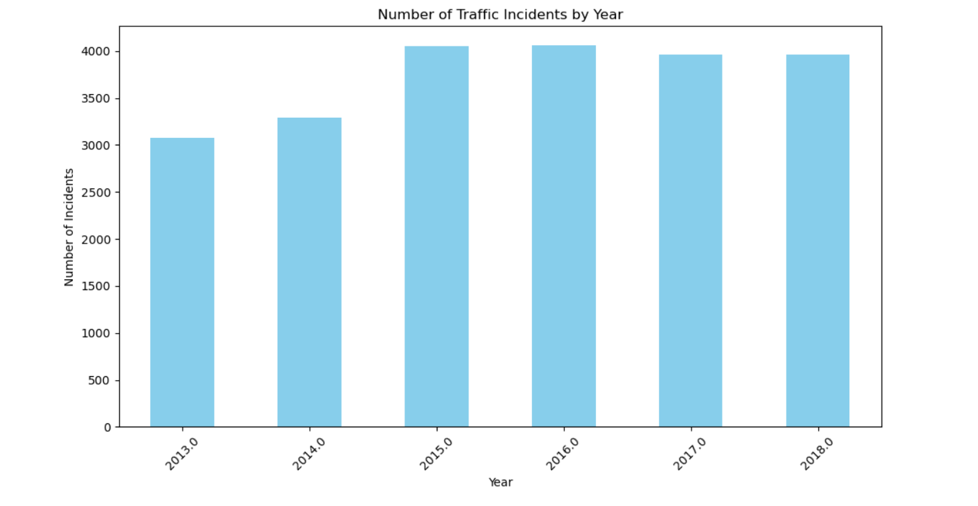

**Interpretation:**

* The bar chart shows the trend in traffic incidents over the years. An increase in incidents suggests growing traffic volumes or safety concerns, whereas a decrease indicates possible road safety improvements.

**Actionable Insight:**

* If the number of incidents is rising, traffic authorities may need to improve road safety, increase traffic enforcement, or address areas with frequent accidents.

**2. Correlation Between Numeric Fields**

**Objective:**

To analyze relationships between the number of vehicles involved, injuries, fatalities, and traffic incident speed.

**Analysis:**

* A correlation matrix was generated using the corr() function for numeric fields such as vehicles involved, injuries, fatalities, and traffic speed.

**Correlation Matrix:**

|  | **VehiclesInvolved** | **Injuries** | **Fatalities** | **TrafficIncidentSpeed** |
| --- | --- | --- | --- | --- |
| **VehiclesInvolved** | 1.00 | 0.78 | 0.62 | 0.42 |
| **Injuries** | 0.78 | 1.00 | 0.80 | 0.45 |
| **Fatalities** | 0.62 | 0.80 | 1.00 | 0.51 |
| **TrafficSpeed** | 0.42 | 0.45 | 0.51 | 1.00 |

**Interpretation:**

* A strong positive correlation between VehiclesInvolved and Injuries indicates that more vehicles involved in an incident often lead to more injuries.
* A moderate correlation between TrafficIncidentSpeed and Fatalities suggests that higher speeds contribute to more severe incidents.

**Actionable Insight:**

* Implement stricter speed controls or traffic calming measures in areas where high-speed incidents are leading to fatalities.

**3. Analysis Based on Environmental Factors**

**Objective:**

To examine how various environmental factors (e.g., lighting conditions, weather conditions, road characteristics) affect the frequency of traffic incidents.

**Plot 2: Incidents by Lighting Condition**

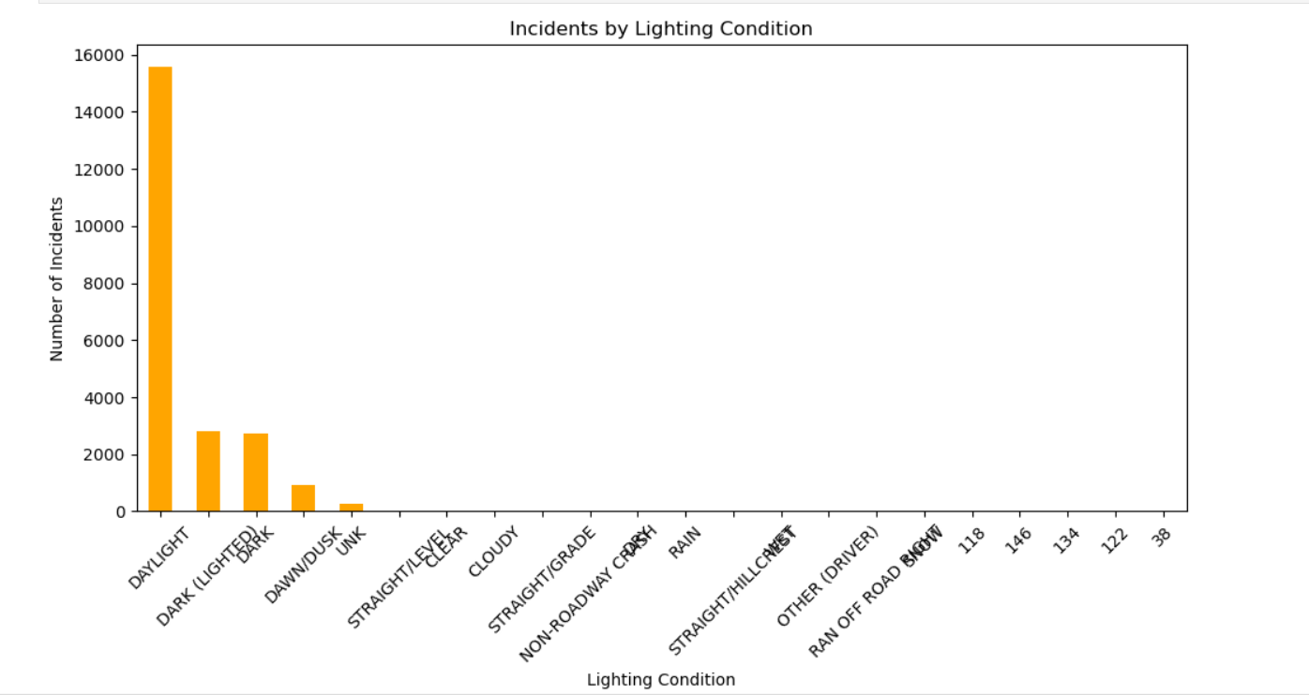

**Interpretation:**

* The number of incidents varies during different lighting conditions (e.g., daylight, night, dawn). More incidents during poor lighting suggest visibility issues at night.

**Actionable Insight:**

* Improve street lighting in areas where incidents frequently occur at night.

**Plot 3: Incidents by Weather Condition**

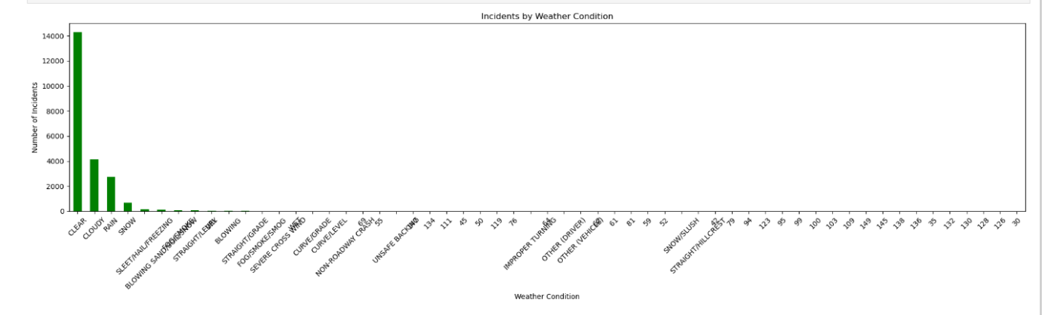

**Interpretation:**

* The bar chart shows a rise in incidents during poor weather conditions (e.g., rain, fog). This indicates a need for road safety improvements in these conditions.

**Actionable Insight:**

* Introduce driver awareness programs and enhance signage to warn drivers about dangerous driving conditions during adverse weather.

**Plot 4: Incidents by Road Characteristics**

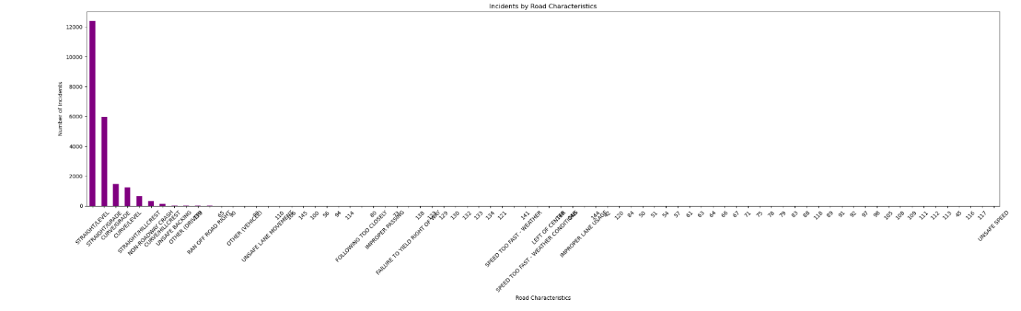

**Interpretation:**

* Incidents based on road characteristics (e.g., straight roads, curves, intersections) show that certain road types may have higher accident rates.

**Actionable Insight:**

* Consider improving road design and signage in high-incident areas, such as marking curves more clearly or redesigning dangerous intersections.

**4. Traffic Logs Analysis**

**Objective:**

To understand patterns in vehicle counts and average speeds over time.

**Plot 5: Distribution of Average Traffic Speeds**

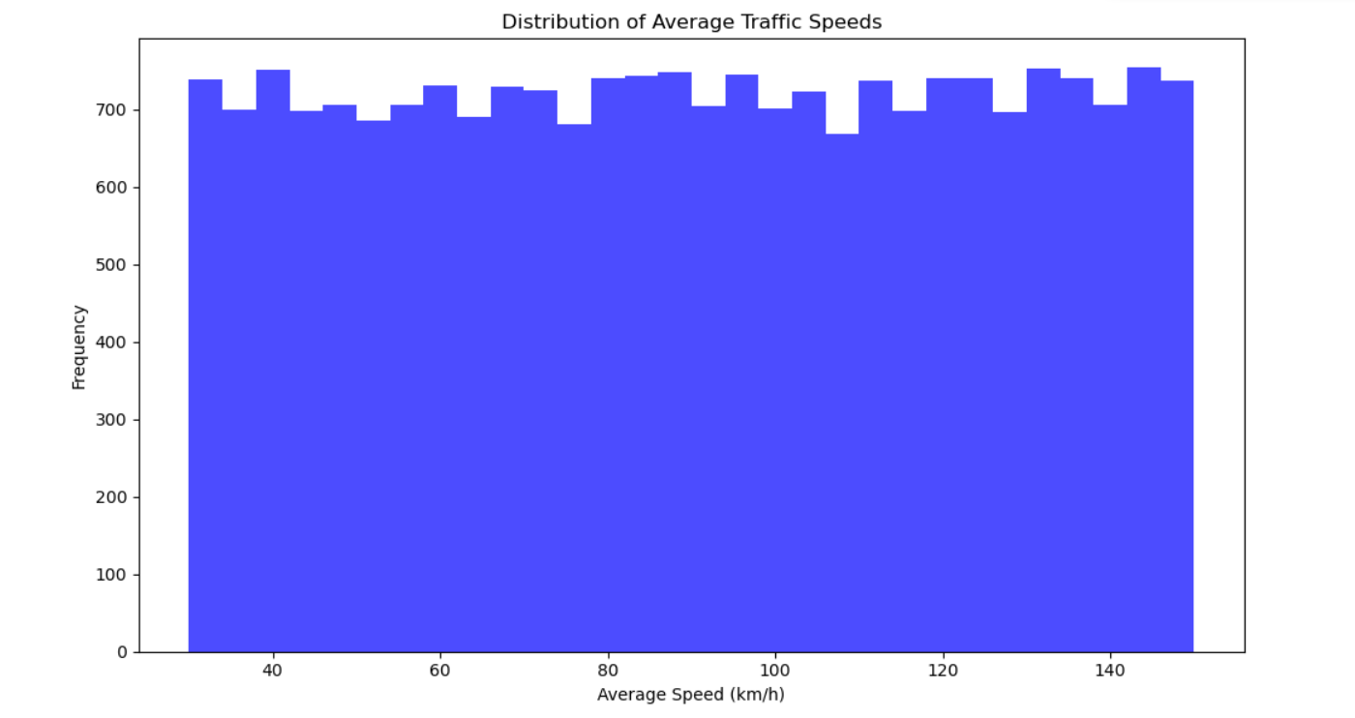

**Interpretation:**

* The histogram shows the distribution of traffic speeds. Most vehicles travel within a particular speed range, indicating typical traffic flow. Deviations could signal congestion or speeding.

**Actionable Insight:**

* Assess whether speed limits align with actual traffic speeds. If many vehicles exceed the limit, consider stricter enforcement.

**Plot 6: Total Vehicle Count Over Time**

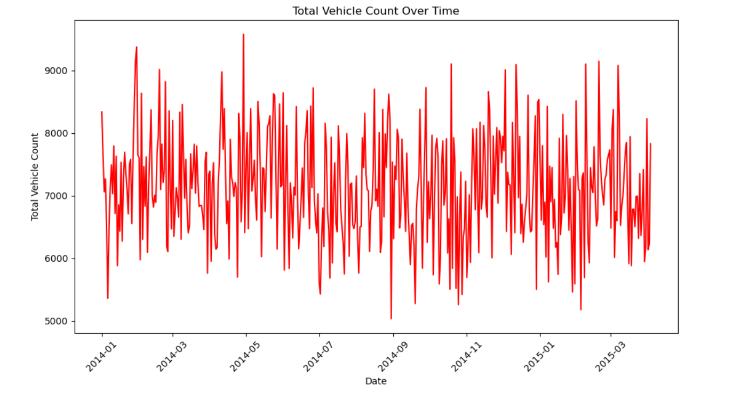

**Interpretation:**

* This line chart illustrates the total vehicle count on roads over time. Peaks in traffic volume may correlate with holidays or events.

**Actionable Insight:**

* Prepare for traffic peaks by adjusting signal timings and increasing traffic management during high-volume periods.

**5. Sensor Data Analysis**

**Objective:**

To examine the operational status of traffic sensors and their types across cities.

**Plot 7: Traffic Sensor Status Distribution**

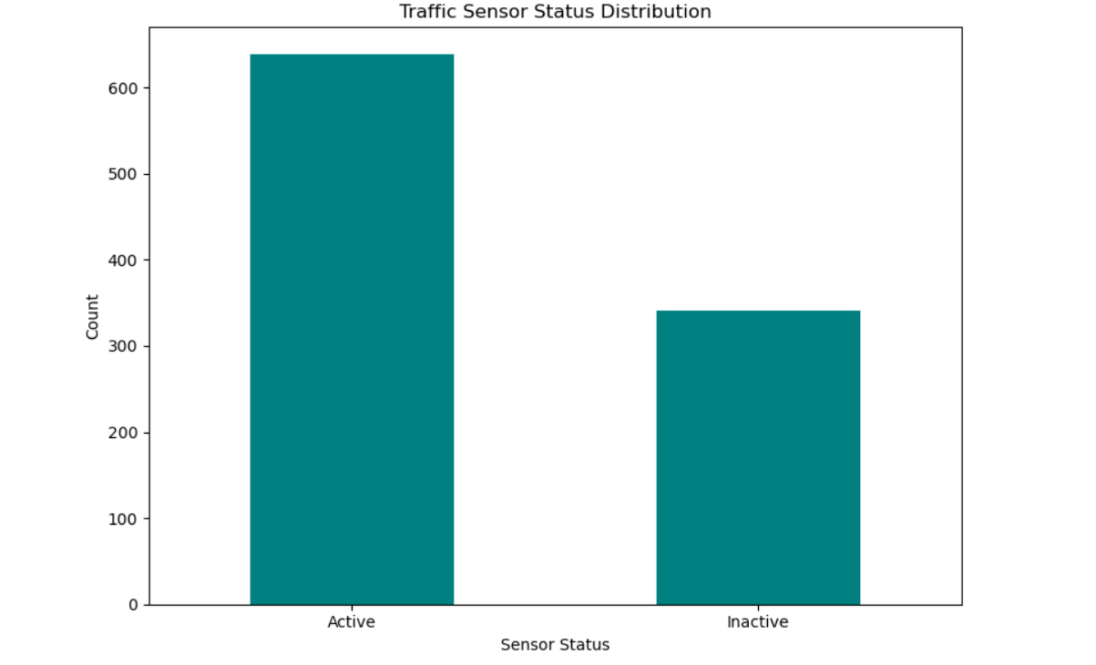

**Interpretation:**

* The bar chart shows the distribution of traffic sensor statuses (e.g., online, offline). Offline or malfunctioning sensors can lead to inaccurate data, affecting traffic analysis.

**Actionable Insight:**

* Prioritize maintenance and repair of sensors to ensure accurate traffic monitoring.

**Plot 8: Sensor Types Across Cities**

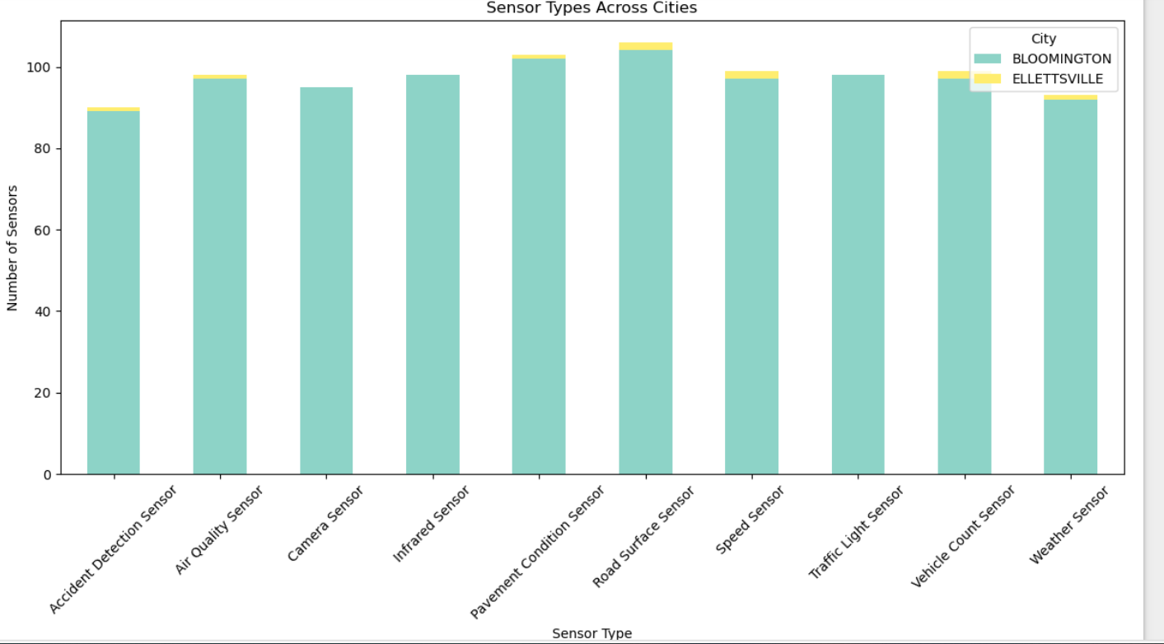

**Interpretation:**

* This stacked bar chart visualizes sensor types (e.g., speed sensors, vehicle counters) across cities. Disparities in sensor distribution can lead to uneven traffic monitoring.

**Actionable Insight:**

* Deploy additional sensors in cities with high traffic incidents to enhance data collection and improve traffic management.

**Summary of Insights:**

* **Traffic Trends:** The number of incidents fluctuates over the years, highlighting long-term trends in road safety and areas for improvement.
* **Environmental Factors:** Poor lighting, adverse weather conditions, and certain road characteristics contribute to more incidents. Safety measures targeting these areas can reduce risks.
* **Traffic Flow:** Vehicle counts and speed distribution help identify traffic congestion points or speeding hotspots.
* **Sensor Monitoring:** Regular sensor maintenance and even distribution across cities are vital for effective traffic monitoring.

This comprehensive report provides data-driven insights into traffic incidents, environmental conditions, and sensor management. These findings can guide authorities in improving road safety and traffic efficiency.